DELAWARE VALLEY MIDDLE SCHOOL
"Where Dreams Become Reality"

THREE TIMES THE FUN: Our terrific trio of Odyssey of the Mind teams has been hard at work preparing for the Northeast PA Regional Tournament, which will be held on Saturday, February 22nd at Pocono Mountain West High School in Pocono Summit, PA. Teams that place first or second at Regionals will advance to State Finals, which will be held on Saturday April 5th at Pocono Mountain East High School in Swiftwater, PA.

Problem 1: The OM-Mazing Race: Mrs. Nielsen & Mrs. Monahan's vehicle team (Paul Barcia, Mackenzie DiMarisico, Calder Laubin, Jake Bischoff, Bradley Gaa, Maeve Kaiser, and Maryah Nuhn) is designing and creating an all-terrain vehicle that transports riders on a race for a prize. Each leg of the race will include an obstacle that the rider and vehicle must overcome. Their skit sounds WHEELY exciting!
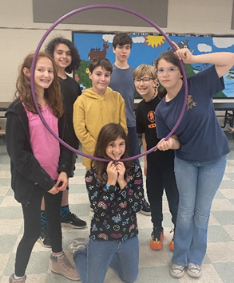

Problem 2: Mech-Animal Sidekick: Mrs. Lockwood's Technical team (Christopher MIller, Patty Chen, Jojo Nielsen, Ariel Weyant, Michael Simmons, Addy Gamer, and Keston Monahan) is designing and creating an original robotic animal that has the ability to make people happy. During the skit, the Mech-Animal will perform various tricks to cheer people up and will then disappear and be found in an very unusual place. Their pirate-themed skit is sure to be a TREASURE!
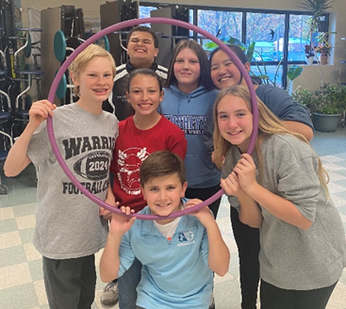
Problem 4: Save Me Structure: Mrs. Orgitano's Structure team (Taryn Kaylor, Sekai Jones, Jovey Thiele, Dominic DeLauro, Mia Pavinich, Connor Stewart, and Gabriel O'Sullivan) is creating a performance about an unusual animal rescue character who needs to find homes for balsa wood and glue animals. The animal rescue character will test if a home is safe by balancing and holding as much weight as possible. We can't WEIGHT to see their solution!
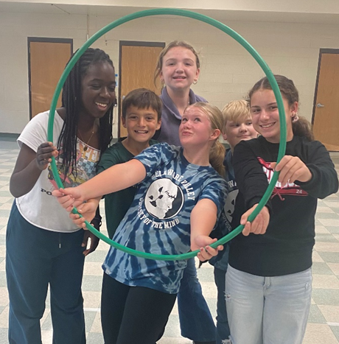

SNOWAY: The Ski and Snowboarders club have experienced some chilly, but mostly cooperative conditions this year. While only a few trips remain, the group continues to enjoy time together and racing down the slopes. Students from all three grades take part in this club and Shawnee Mountain continues to be an outstanding host mountain.

ATLETIC TRYOUTS: Spring tryouts will take place on Monday March 3rd. To participate in a tryout, you MUST have a cleared physical dated May 2024 or after and prior to March 3rd. Completed physicals must be uploaded into planeths.com.

#1 SPELLER: DVMS held its annual Spelling Bee on January 13, 2025. The bee ran for an impressive record setting 31 rounds with 17 super speller students competing. The top speller was 7th grader, Wyatt Malenczak; runner-up was Maryah Nuhn. Congratulations, Wyatt, and all outstanding spellers!
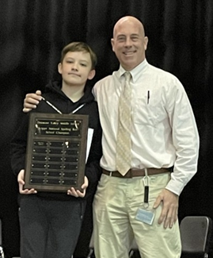
Wyatt Malenczak & Principal, Dr. Pete Ioppolo

CHANGING OUR WORLD: Marking the beginning of Black History Month, Mrs. Shedlauskas has created a bulletin board offering a variety of reading opportunities promoting some of the most historical world change agents. The bulletin area outside of the library showcases an extraordinary group of individuals that have helped to change our world across many facets of business, industry, and entertainment.
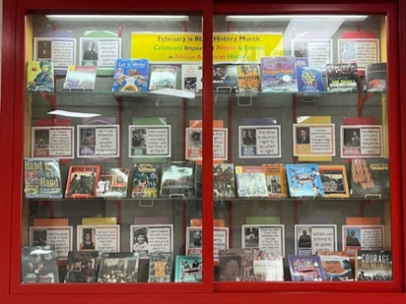

CO-CURRICULAR STUDENT OF THE MONTH
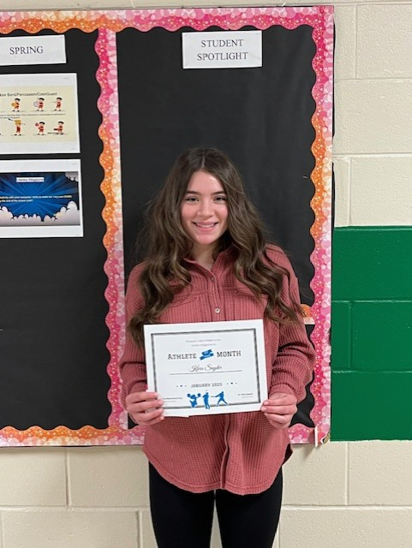
Kiera Snyder – Girls Wrestling

JANUARY TEACHER OF THE MONTH
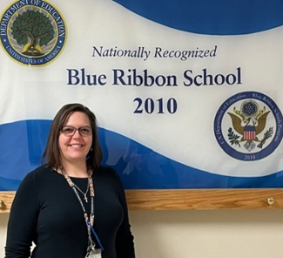
Mrs. Reece, Music Teacher
JANUARY STUDENT OF THE MONTH NOMINEES

Murad Aziz Lillian Hall-Belluscio Lorelei Hoeper Kai Gara
Adalie Lewis Keston Monahan Maryah Huhn Sage Stead
Hope Sybrandy Melanie Weeks Bella Paradiso Max Weber
Rocco Paradiso Addison Pousley Michael Simmons Hazel Pope
Lydia Boronow Surie Chen Caitlyn Feely Patty Chen

JANUARY STUDENTS OF THE MONTH
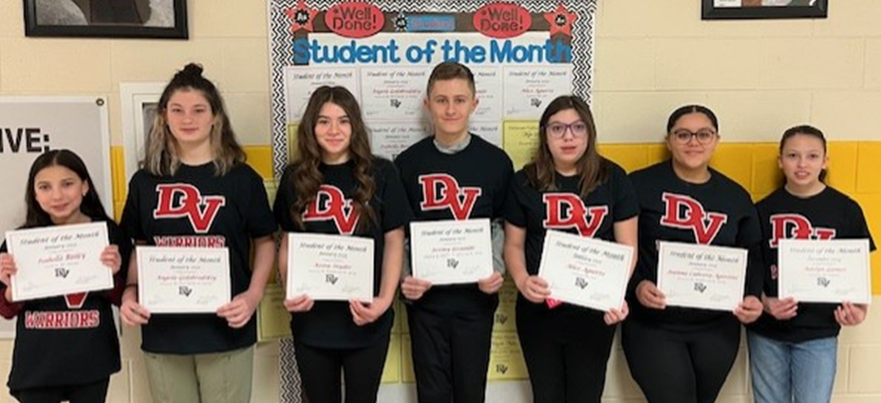
Isabella Bailey, Angela Golobrosky, Kiera Snyder, Jeremy Gesualdo, Alice Aguirre, Joanna Cabrera-Agostini, Adelyn Gamer

FEBRUARY HAPPENINGS

February 12 DVMS/DVES/SES 5th & 6th Grade Combined Chorus concert 6:30 DVHS Auditorium
February 17 School Closed, President’s Day
February 27 DDMS/DVMS 7th & 8th Grade Combined Chorus concert 6:30 DVHS
Auditorium

We are now quickly making our way through the middle of the third marking period. The students have begun receiving and making recommendations for the following school year. These placements are derived based on student academic performance. It is imperative that you encourage your children to provide their best effort so the most accurate assessment of their abilities can be made. Tutoring is available after school to support instruction, if needed. If you have concerns, please reach out to the teacher for a discussion.

Hopefully, the winter will continue to dissipate, and we will soon be moving toward some beautiful spring sunshine. Our staff continues working hard and we all appreciate your continued support. Best regards for a wonderful and safe month!

Sincerely,

Pete Ioppolo, Ed. D.
Principal

