**HEALTH LESSON #2**

**Hi Kids and Families,**

**Hope you are doing well. I hope you were able to get on Brainpop Jr last week and watch the medicine video. That Moby is so funny, and Annie really is a good friend to him and teaches him how to be safe with medicines. Today for our Health Lesson we will be learning about what caffeine is.**

**CAFFEINE IS: A DRUG THAT SPEEDS UP THE NERVOUS SYSTEM AND COULD CAUSE HEART RATE TO INCREASE.**

Here are some examples of foods and drinks with caffeine. Can you name these?

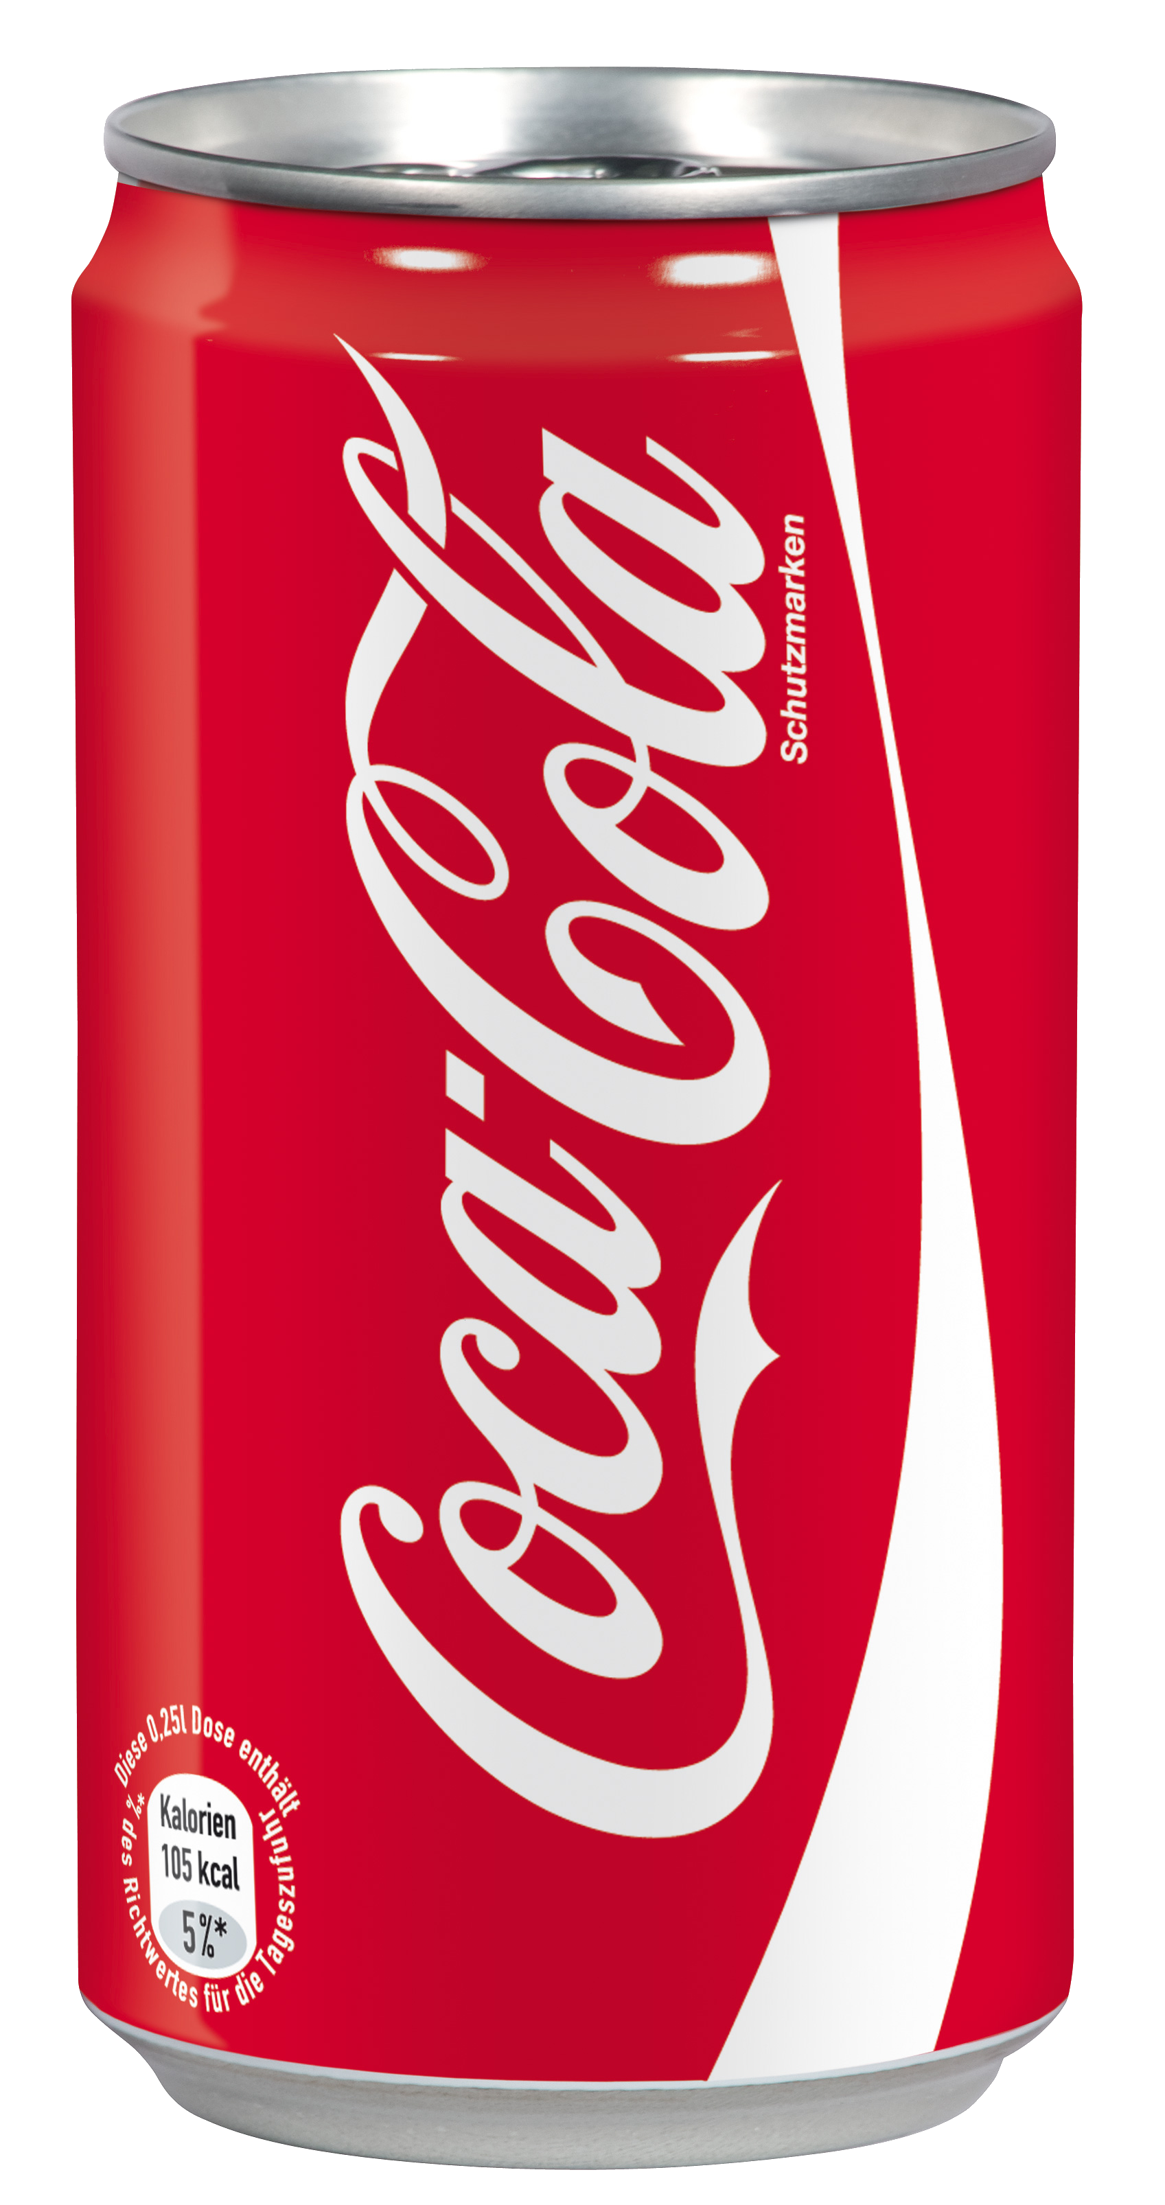 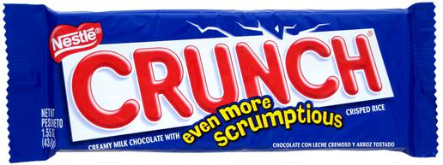

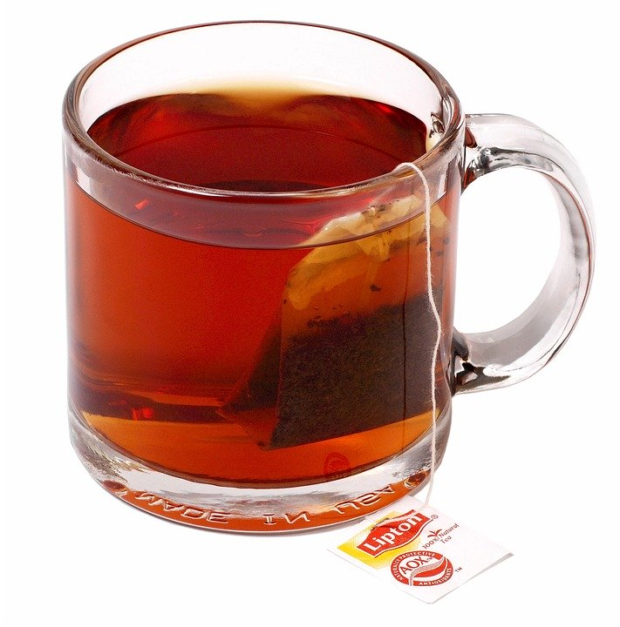 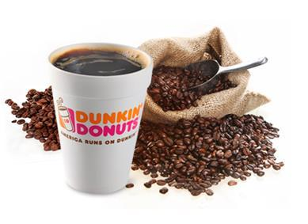

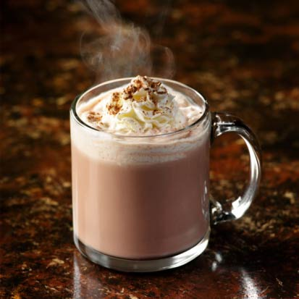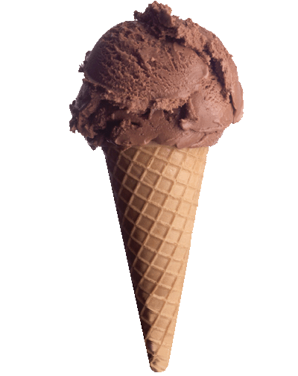 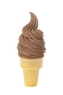

Were you able to name all the pictures? Foods and drinks with caffeine in them may make you feel hyper and full of energy. Some foods with caffeine in them are not good for kids to have. For example, coffee and tea have a great amount of caffeine in them and are adult drinks. Some drinks are **caffeine free or decaf. This means that this food or drink does not have caffeine in it. This would be a healthy choice!** Having a candy bar, soda or ice cream sometimes is fine! Just don’t overdo it!

**ANSWER YES OR NO:**

1. **Does most chocolate have caffeine in it? yes or no**
2. **Caffeine could make you sleepy. yes or no**
3. **Caffeine could raise my heart rate yes or no**

**Next week I will post the correct answers for the questions so you can check if you were right! Have a great day! 😊**