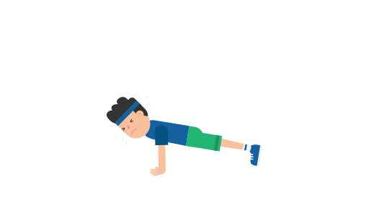Physical Education Lesson #2

Hey guys,

It is important that we stay active, so our bodies remain healthy and strong! This lesson will begin with our warm-up activity to get the blood flowing and to loosen up our muscles. Following our warm-up, there will be three different exercises that we would like everyone to try. There will also be videos of me demonstrating them. Try your best. Remember some things may be more difficult than others, but practice makes perfect! And have fun with it, we miss you! -Mr. Feiss and Mrs. Miller

**Begin with warm-up:**

If you can get outside that will be best. Make sure there is an adult with you. Get a drink if you need in between!

- Speed walk for 1 minute

- Jog for 1 minute

- Stop and stretch- reach to sky and touch your toes

- Skip for 1 minute

- Stop and do 10 arm circles front and 10 arm circles backwards

- Gallop for 1 minute

- Stop and do 10 jumping jacks

SEE BELOW FOR EXERCISES WITH PICTURES



**Exercise #1**

**10 Push Ups**: If you need to keep your knees on the floor that’s fine. Try to keep your back flat and head up.



**Exercise #2**

**10 Crunches:** Try to bring your elbows to your knees!

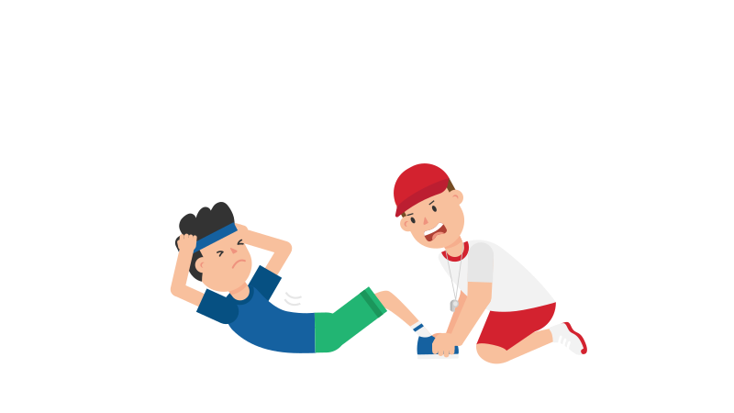

**Exercise #3**

**10 Squats**: Act like you’re trying to sit in a chair!

***If you would like to see what the exercises look like check out the videos on Mr Feiss’ Teacher page at dvsd.org. Go to DDPS site and click on Special Area Teacher Section and Click on Mr. Feiss.

