DDPS PHYSICAL EDUCATION LESSON #1

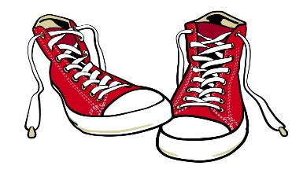

[This Photo](http://superawesomevectors.deviantart.com/art/Converse-Shoes-Free-Vector-624701900) by Unknown Author is licensed under [CC BY](https://creativecommons.org/licenses/by/3.0/)

**Hi Kids and Parents!!!**

**Hope you are doing great. We really miss you! Please try to participate in as many activities as you can each day! Mr. Feiss and I will try to send you different things to do to stay healthy. Make sure you have a parent with you when you are completing the activities!! Everyone should have a tablet or computer to use for the activity if possible.**

**#1. Let’s start with our warm-up! If you can put music on that would be great! If you have a watch to use that would be great if not, just stop and start on your own!**

* **Start with speed walking around your yard or indoor space. After 1-minute start to jog for 1 minute**
* **Stop and do our first stretch: Reach to sky and Touch Toes 2 times**
* **Next: Skip for 1 minute**
* **Stop and do your second stretch. Arm Circles: 10 Front and 10 back**
* **Next: Gallop for 1 minute**
* **Stop and do last exercise: 10 jumping Jacks**
* **Please walk for 1 minute**

**Our Activity today will focus on raising your heartbeat!! If possible, please go to the website listed below and follow these fun exercises to raise your heartbeat. Please have you and your parents go to Youtube.com and search Physical Activities for Kids: Get Active at Home! Click on the video and have fun!**

[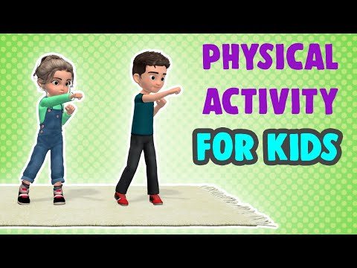](https://www.youtube.com/embed/3_oIssULEk0?feature=oembed)

**Please check your pulse when you can. Remember place two**

**fingers on the side of your neck:**

**Was your heartbeat fast or slow? **



[This Photo](https://commons.wikimedia.org/wiki/File:Pulse_(Neck).png) by Unknown Author is licensed under [CC BY-SA](https://creativecommons.org/licenses/by-sa/3.0/)

**Hope you had fun trying some of these exercises! If you would like to tell us how you did please email Mrs. Miller at** [**MillerA@dvsd.org**](mailto:MillerA@dvsd.org) **or Mr. Feiss at** [**FeissJ@dvsd.org**](mailto:FeissJ@dvsd.org) **.**

KEEP MOVING!!!!

Mrs. Miller & Mr. Feiss