ANIME CLUB
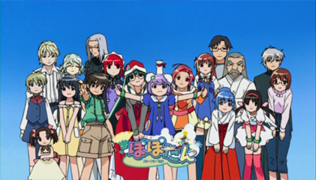
Come join us to learn about and appreciate:
- Japanese language
- Japanese schools
- Holidays in Japan
- Cosplay
- And so much more!
- Anime
- Daruma
- Asian religion
- Asian cuisine
- Onigiri
For more information contact club advisor Ms. Joanna Broughton
broughtonj@dvsd.org

